Using Tampons

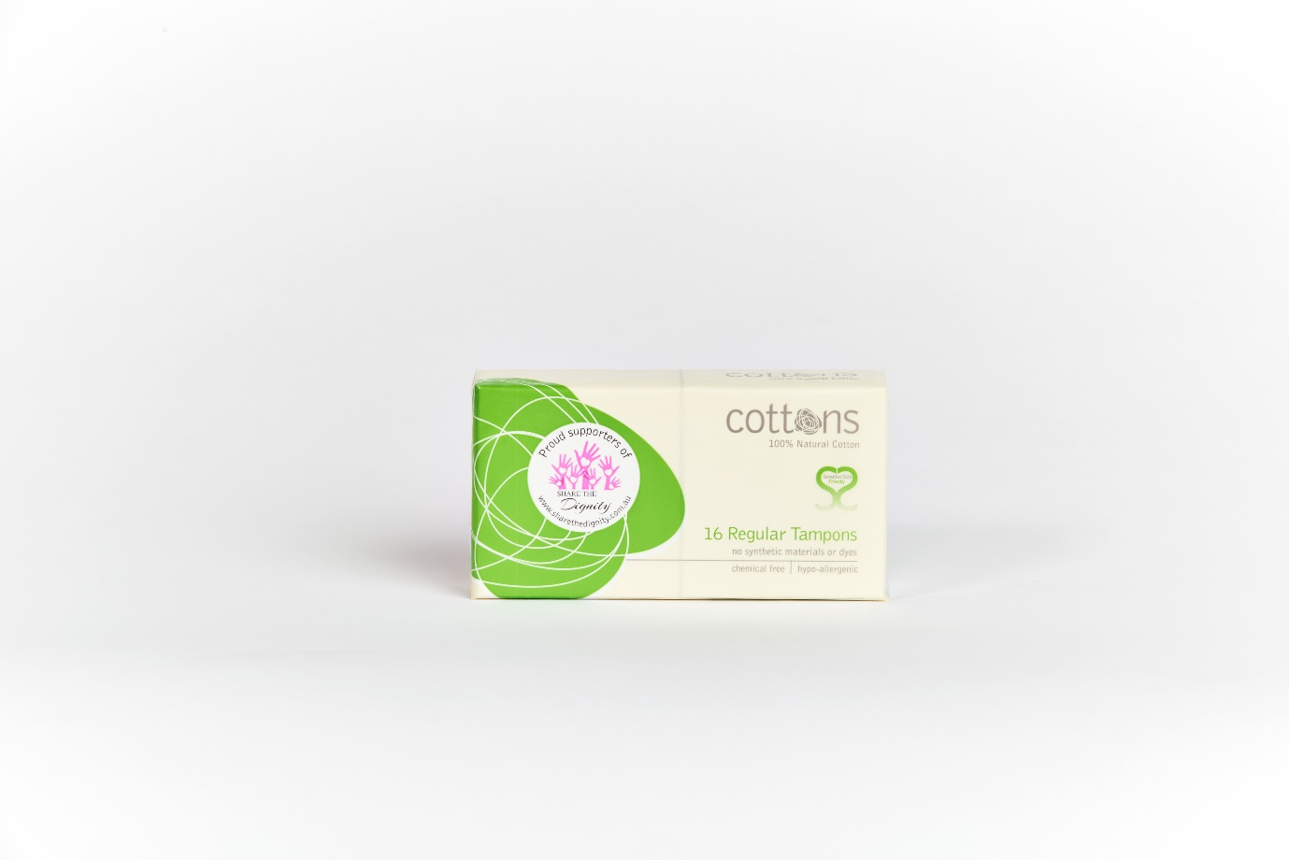

 



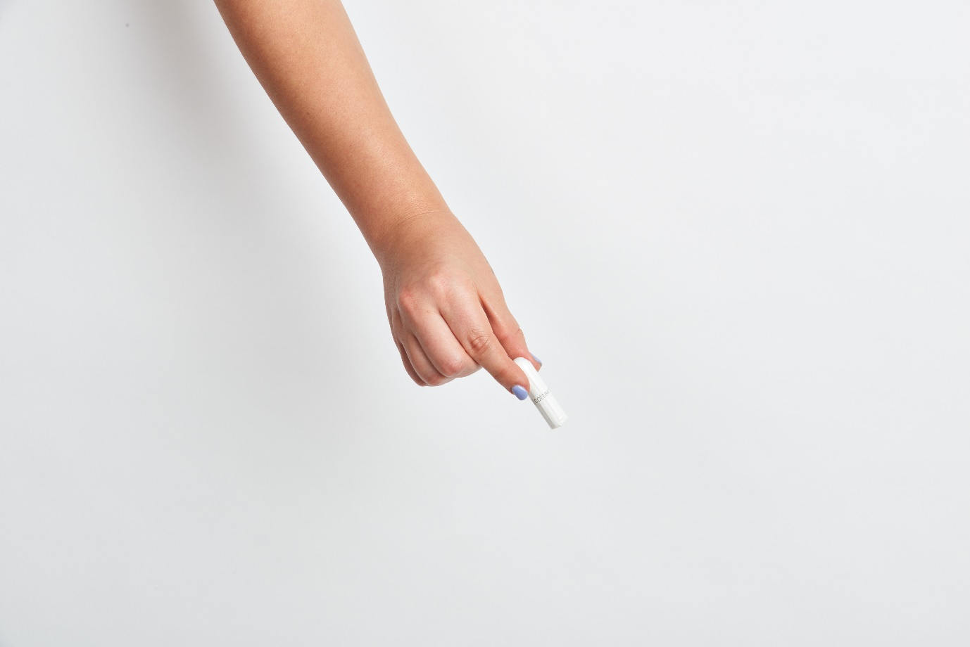

Tampons are white cotton plugs. They catch the blood when you have your period. Tampons are put inside your vagina.

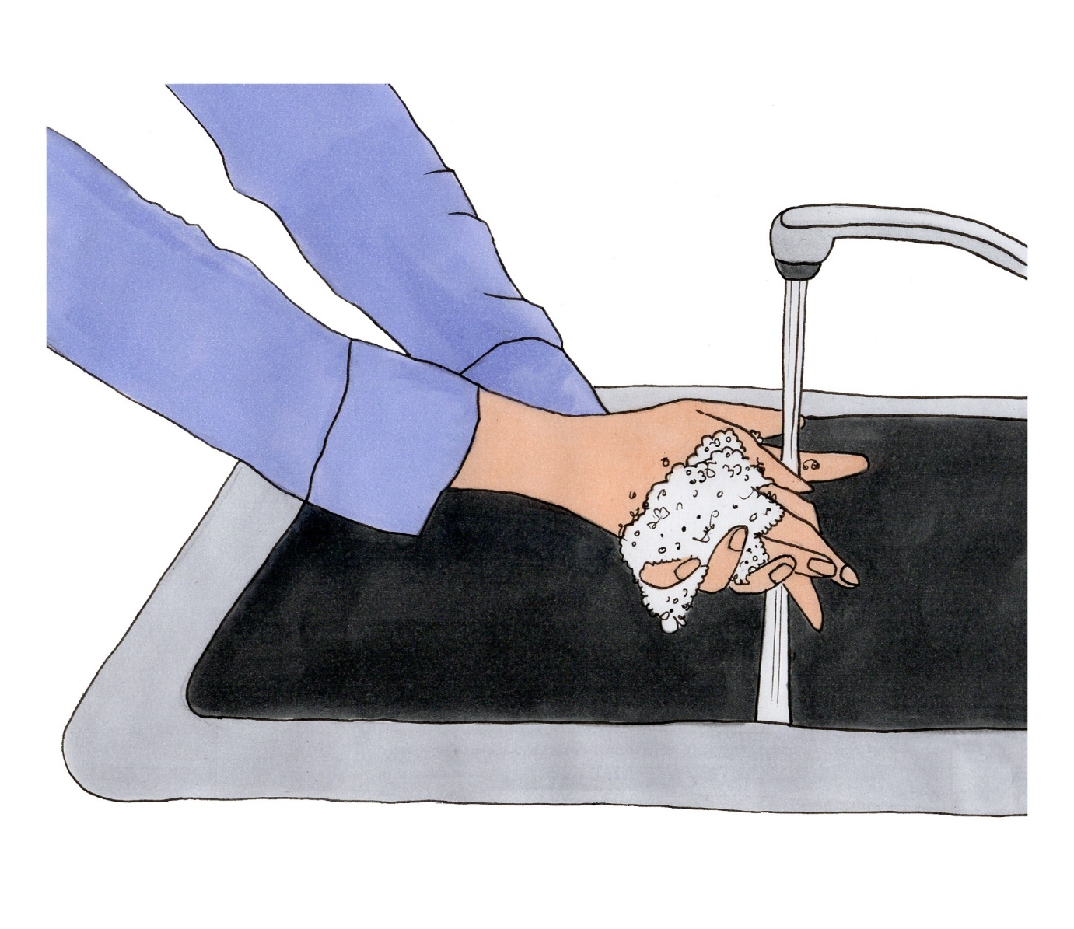

Wash your hands first before you touch the tampon.

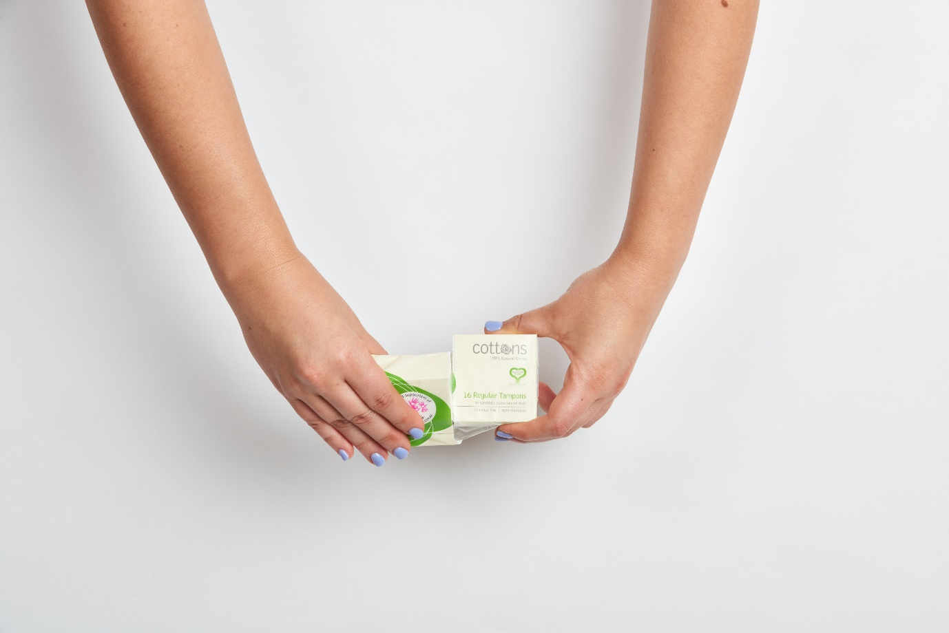

Tampons come in boxes covered in plastic. Rip the plastic off and open the box. Put the plastic in the bin.

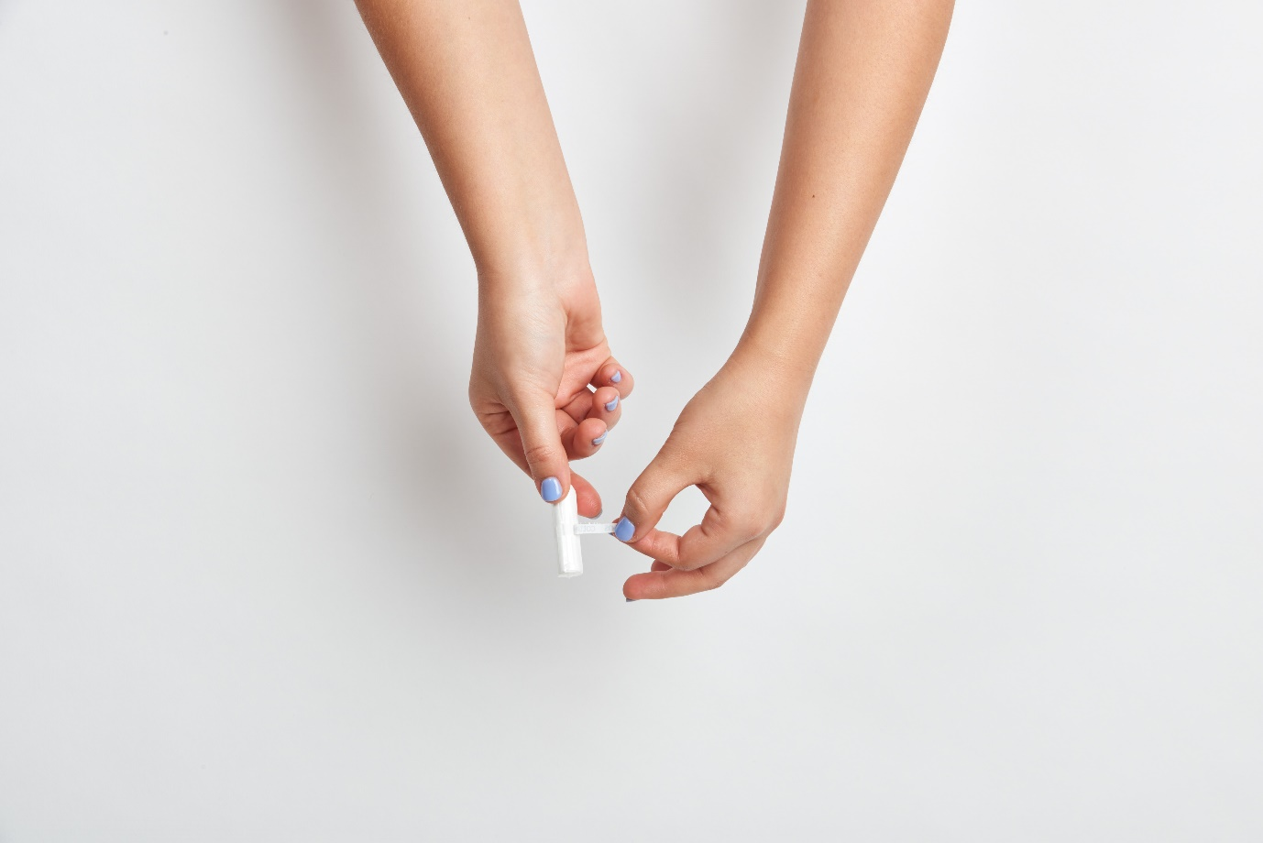

Hold the tampon by its end. Swipe you finger over the white strip until you find the opening. Rip the white plastic tab off. It will pull off.

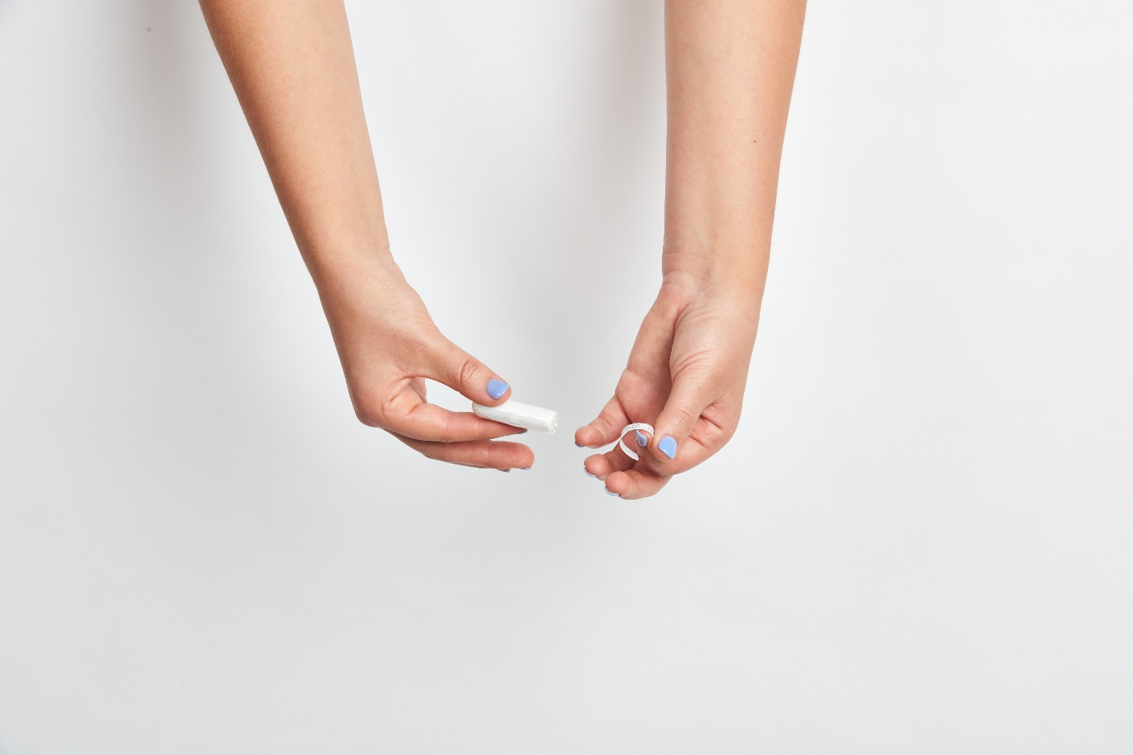

Take the plastic cover off at both ends. First hold the round end then pull the flat end plastic off. The flat end is where the string is. Pull the string out and hold the tampon by the string. Then take the plastic off the round end.



**Anus**

**Urethra**

**Vagina opening. This is where the tampon goes.**

A tampon is pushed into your vagina. It stays there and soaks up the blood. The blood won’t leak out. The string stays outside of your body.

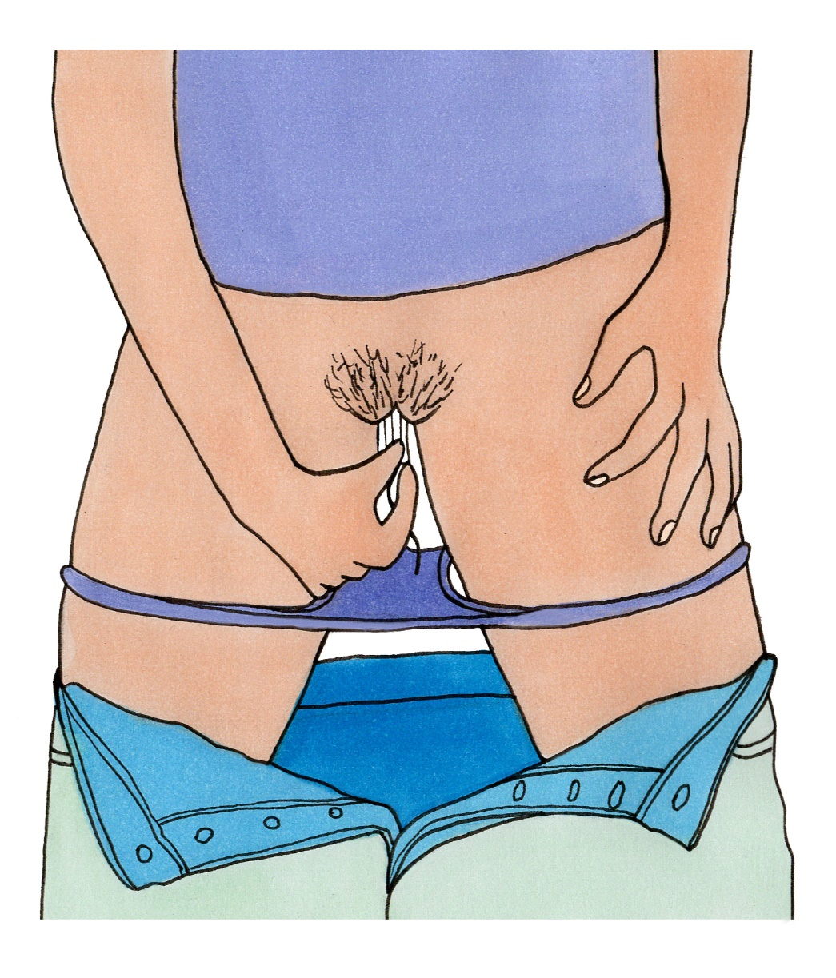

The tampon is pushed into your vagina. The muscles in your vagina hold the tampon in. Sometimes squatting can make this easier to push the tampon in. Sometimes putting one leg up high can help.

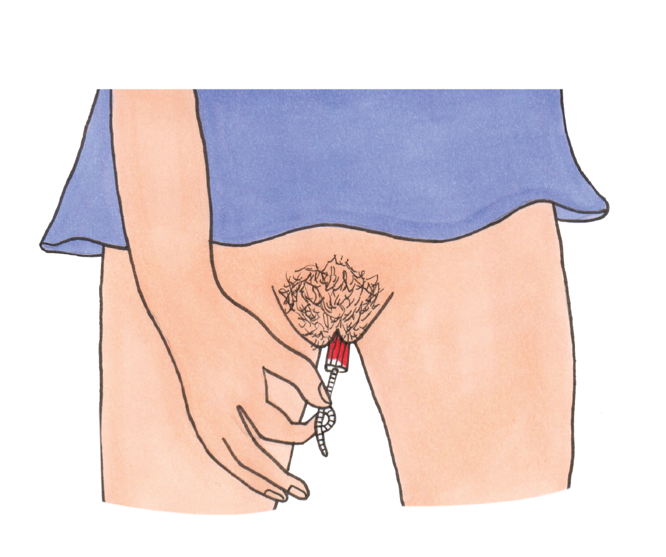

Tampons have to be changed every 4 hours. This is so it won’t leak. It is also good for your body. Pull on the string gently and the tampon will come out.

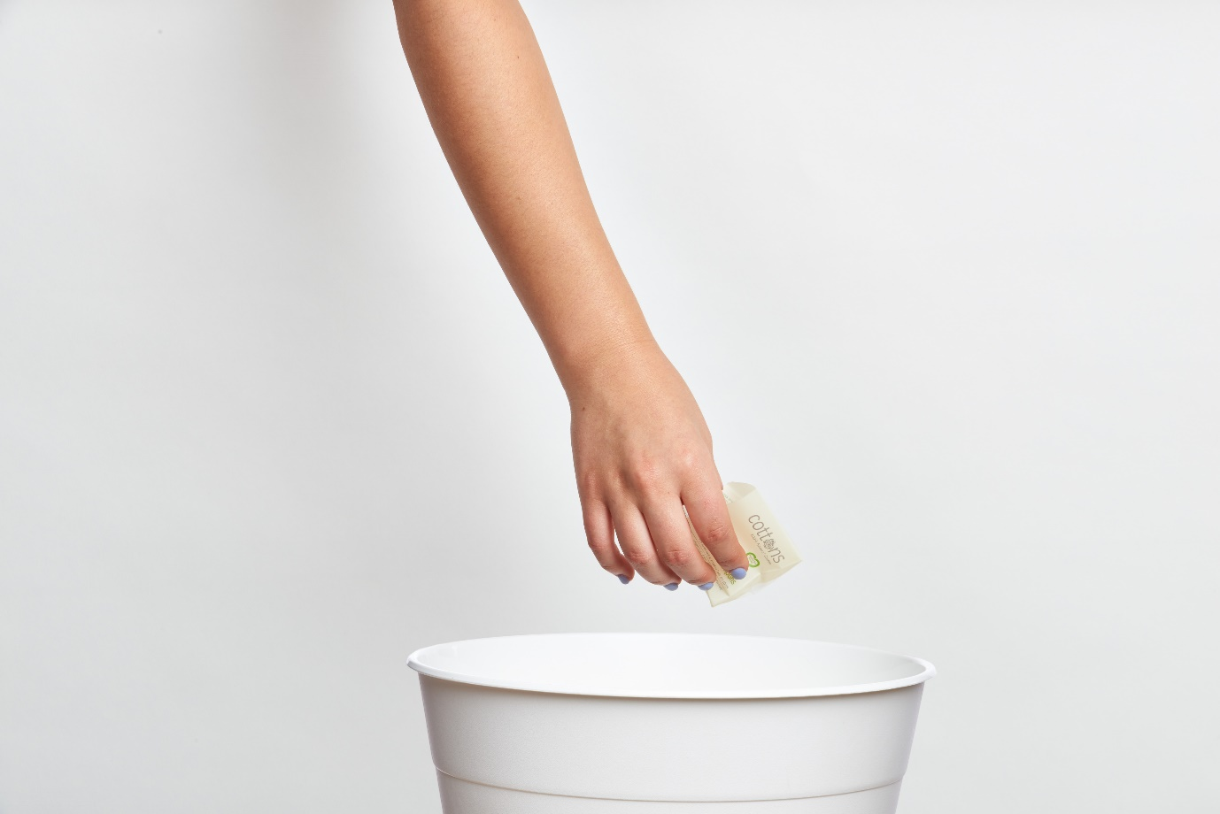

Wrap the used tampon in toilet paper. Used tampons go into the bin.



Always wash your hands after changing a tampon.

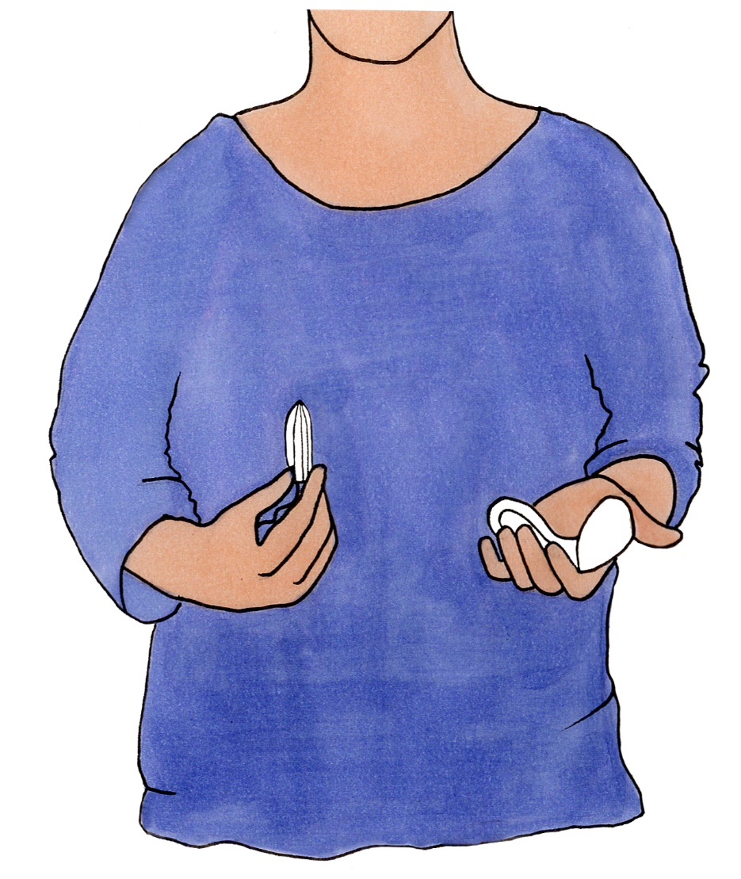

Tampons can take some time to get used to. Some girls wait until they are older. It is ok to use either pads or tampons.

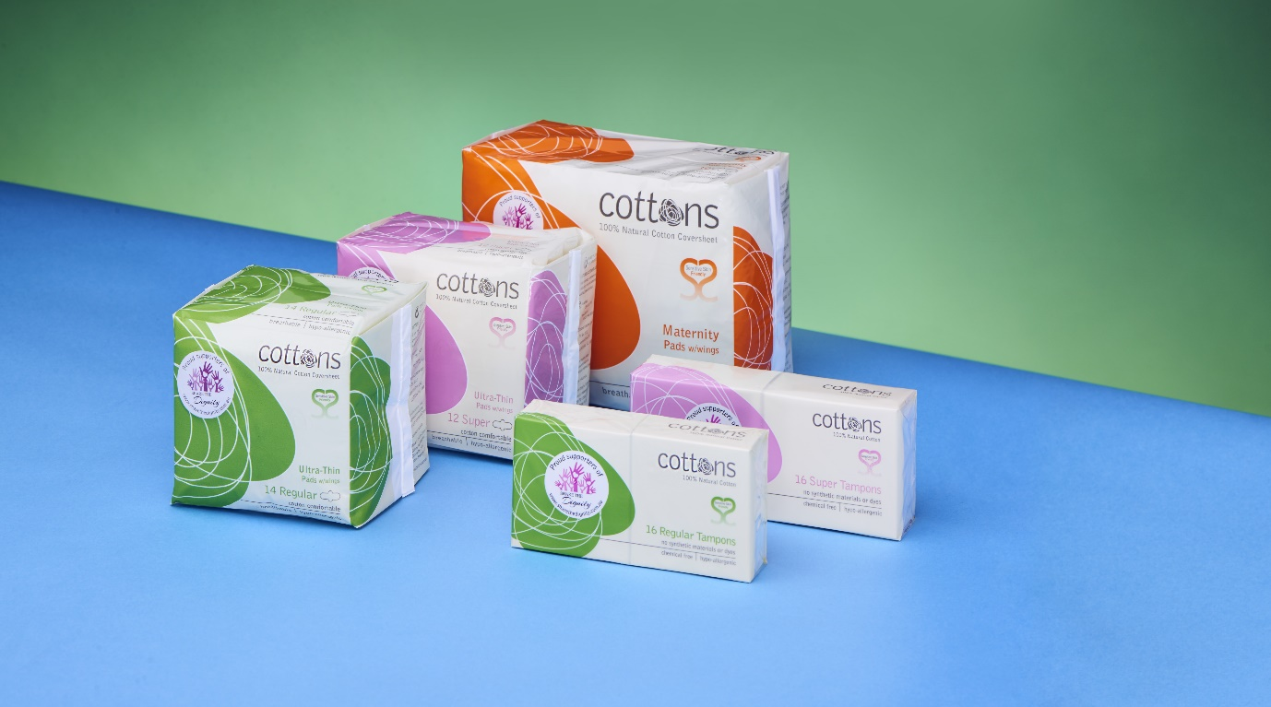

Tampons come in different sizes. They can hold different amounts of blood. Mini tampons are for less blood flow. Super tampons are for heavier blood flow and can hold more blood.

This resource was created by Amaze in partnership with Cottons and Family Planning Victoria.

Amaze

amaze.org.au

[(03) 9657 1600](https://www.google.com/search?q=amaze+autsm&rlz=1C1EJFC_enAU831AU831&oq=amaze+autsm&aqs=chrome..69i57j0l5.5062j1j4&sourceid=chrome&ie=UTF-8)

24 Drummond St, Carlton VIC 3053

Cottons Pty Ltd

cottons.com.au

(03) 9465 5033

46 Enterprise Dr, Bundoora VIC 3083

Family Planning Victoria

fpv.org.au

[1800 013 952](tel:1800013952)

901 Whitehorse Rd, Box Hill VIC 3128

© Amaze 2019